# B.Tech project REPORT

# ON

# PRIVACY PRESERVING LOCATION DATA PUBLISHING

**by**

**Chintapalli Narendra(11912099)**

**Under the Supervision Of**

**Ms.Mamtesh mam, Assistant Professor**.



## Department Of Computer Engineering

### National Institute of Technology,Kurukshetra.



CERTIFICATE

This is to certify that the project report entitled ”PRIVACY PRESERVING LOCATION DATA PUBLISHING” submitted to the Department of Computer Science and Engineering, NIT Kurukshetra, in partial fulfillment for the award of the degree of Bachelor of Technology in Computer Science and Engineering, is a record of bona fide work carried out by Mr.Narendra, Roll No. 11912099, under my supervision and guidance.

All help received by him from various sources have been duly acknowledged.

No part of this report has been submitted elsewhere for award of any other degree.

Signature of supervisor:

(**Ms.Mamtesh)**

TABLE OF CONTENT

|  |  |
| --- | --- |
| TOPIC | PAGES |
| Abstract | 4 |
| Introduction | 4-6 |
| Motivation | 6 |
| Literature Survey | 6-7 |
| System analysis | 7-8 |
| Proposed Approach | 9-17 |
| Data flow diagrams | 18 |
| Conclusion | 18 |
| Source code | 18-23 |
| Results | 23-31 |
| References | 31-32 |

ABSTRACT:

The publication of datasets is critical for open data research and government transparency. Such data publishing, however, may expose users' personal information. Spatial-temporal trajectory datasets are one of the most sensitive data sources. Users' privacy cannot be protected simply by eliminating unique identifiers. Adversaries may be aware of portions of the trajectories or have the ability to link the released dataset to other sources to identify users. As a result, before publishing spatiotemporal trajectory datasets, it is critical to use privacy-preserving procedures. Machine learning-based anonymization is proposed in this research as a viable approach for anonymizing spatiotemporal trajectory information (MLA). We are able to apply machine learning methods for grouping the trajectories by presenting a new formulation of the issue, and we propose to employ the k-means algorithm for this purpose. In extremely sensitive datasets, a variant of the k-means method is also proposed to ensure privacy.

Furthermore, by including multiple sequence alignment as part of the MLA, we enhance the alignment process. The T-Drive, Geolife, and Gowalla location datasets are used to test the framework and the suggested algorithms. The experimental results show that anonymizing datasets using the MLA framework considerably increases their value.

# INTRODUCTION:

Publication of data by many organisations and institutions is essential for open research and transparency in government agencies. Since 2013, data.gov.au, the Australian government's dedicated website for the publication of datasets, has released around 7000 new datasets. Unfortunately, the process of information sharing can be quite dangerous since it may reveal sensitive information about individuals. As a result, removing any personally identifying information from datasets is a must before they are published. However, such an activity is insufficient to protect users' privacy. Malicious users may be able to re-identify users in datasets based on similar traits known as quasi-identifiers, or they may have previous knowledge of the users' trajectories. They can utilize this additional information to expose confidential material that might threaten people's physical, financial, and reputational well-being.

Location trajectories, also known as spatiotemporal trajectories, are one of the most sensitive data sources. Despite the multiple benefits that publishing spatiotemporal data may give to individuals and researchers, it poses a serious danger to their privacy. Consider someone who has been utilising GPS navigation to get from home to work every morning during the week. It is feasible to identify a user if an attacker has some previous information about the user, such as the user's home address. User privacy can be threatened by such an inference attack, which can expose the user's health state and how frequently the user visits his or her medical professional. As a result, anonymizing spatiotemporal datasets before posting them online is essential. If the adversary connects identifiable users to other databases, such as a database of medical information, the privacy issue becomes much more serious. That is why, in today's world, most organizations are hesitant to disclose any spatiotemporal trajectory datasets unless they are protected by an effective privacy-preserving approach.

K-anonymity is a generally recognized privacy metric for the release of spatiotemporal datasets. This measure ensures that every trajectory in the provided dataset can be distinguished from at least k-1 other trajectories. The concept of k-anonymity for spatiotemporal datasets was introduced, as was a generalization-based anonymization technique. The impact of elements like spatiotemporal resolution and the quantity of users who have been disclosed on the anonymization process Improvements to existing clustering methods should be prioritised.They presented a method for obtaining k-anonymity by grouping similar trajectories and deleting the ones that were extremely divergent. More recently, he created the k-merge approach to anonymize trajectory datasets while protecting users' privacy from probabilistic assaults. Suppression and splitting on a local level.

There is no straightforward way to assess the impact of clustering when analyzing the ranges between trajectories rather than just the locations since there is no well-defined mechanism to cluster trajectories. The current literature relies on pair wise sequence alignment, which results in a significant degree of data loss. There is no one metric that can be used to assess and compare the various anonymization processes.

We address the existing challenges in this study by offering an updated anonymization system called machine learning based anonymization (MLA) to protect users' privacy while publishing spatiotemporal trajectory datasets. MLA is made up of two algorithms that operate together: clustering and alignment. We can use machine clustering methods to cluster trajectories by defining the anonymization process as an optimization method and discovering an alternate representation of the system. We suggest using the k-means algorithm for this purpose as part of the MLA framework.

To protect users' privacy when publishing too sensitive spatiotemporal trajectory datasets, we suggest a version of the k 0 -means technique. Multiple sequence alignment, rather than pair wise sequence alignment, improves the performance of sequence alignment in clusters. To assess and compare anonymization schemes, we offer a utility metric. On two real-life GPS datasets with varying temporal and geographic distributions, MLA and its accompanying algorithms are used. The experimental results show that k-anonymity of trajectories may be maintained while much better utility levels can be achieved.

**MOTIVATION:**

Due to the prevalence of mobile devices, all web programmes now capture user locations and store them in their apps, allowing them to monitor users. Some malicious individuals can follow a user's position by identifying their home address and then matching that address with other geographical facts to figure out where the person is going, such as a bank, hospital, or other facility. Many data anonymization approaches, such as K-Anonymity and data perturbation, were introduced to address this difficulty and give security to user location. Data perturbation adds noise to user data while K-Anonymity adjusts data into groups so user location cannot be detected. The current method, which loses a significant amount of information, concentrates on pair wise sequence alignment. Lack of a well-defined strategy for grouping trajectories because it is difficult to quantify the cost of clustering when distances between trajectories rather than just locations are taken into account. To address this issue, we propose a Machine Learning-based data privacy-preserving approach.

**LITERATURE SURVEY:**

The authors suggested an algorithm that, when a user's trajectory reaches an intersection, switches their IDs. By doing this, the programme stops enemies from pinpointing a specific user. Cicek distinguished between sensitive and insensitive position nodes of trajectories. Their suggested technique simply groups the pathways around the delicate nodes and makes use of generalization to generate super nodes. Additionally, Cristina placed the responsibility for maintaining privacy in data posting on the user side. Since they would have more control over their privacy, the writers made an effort to anonymize the data before storing it in the database. Cicek concentrated on the obscuring of the underlying map for sensitive places rather than aggregating trajectories for anonymization. By suppressing important locations, Brito et al. reduced the amount of information lost during the data anonymization process. For trajectory anonymization, the Local Suppression and Splitting approaches were taken into account. The suggested method works well for a limited number of places, but it cannot be used for system models where users can submit inquiries from anywhere on the globe.

Naghizadeh concentrated on the trajectories' stopping locations. This study introduces a sensitivity metric that depends on the amount of time users spend in various areas. To protect user privacy, sensitive areas are moved or replaced with less sensitive ones. Jiang thought of altering locations by introducing noise to protect users' privacy. Noise addition can provide phoney trajectories that don't match realistic conditions.

# SYSTEM ANALASYS

**K-Anonymity :**

It’s built on the idea that by combining sets of data with similar attributes, identifying information about any one of the individuals contributing to that data can be obscured. A release of data is said to have the k-anonymity property if the information for each person contained in the release cannot be distinguished from at least k - 1 individuals whose information also appear in the release. K-Anonymization is often referred to as the power of ‘hiding in the crowd. Data owners who implement k-anonymization effectively can be examples to others, helping to show how data can be anonymized in ways that actually help prevent re-identification of sensitive information.

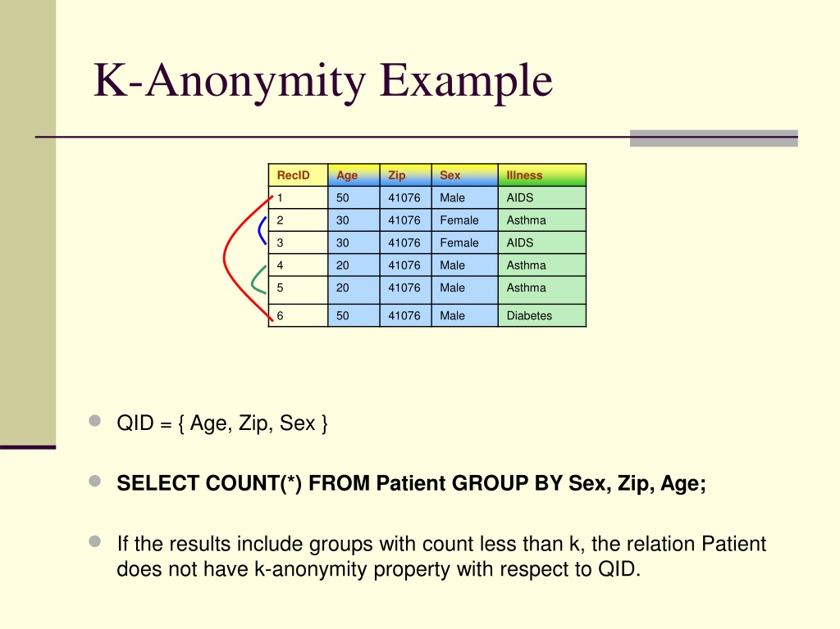

**Data Perturbation :**

Data perturbation techniques are statistically based methods that seek to protect confidential data by adding random noise to confidential and numerical attributes, thereby protecting the original data. These techniques are not encryption techniques, where the data is first modified, then transmitted and then received, decrypted back to the original data.

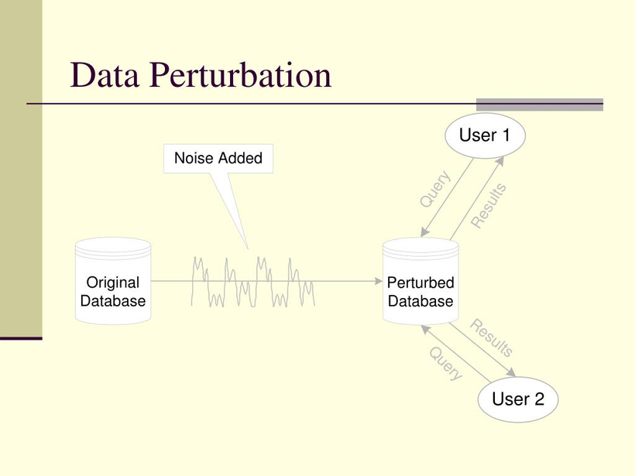

**PROPOSED APPROACH:**

However, the methods described above are unreliable since hostile users can figure out how to break groups and noisy data in order to determine a user's position. To address this issue, we propose a Machine Learning-based data privacy-preserving approach that comprises of three models, each of which provides increased security and anonymization or generalisation that is difficult to understand or crack.

**1)** **Clustering model** **:**

The K-means technique will be used to cluster user locations in this model, similar to k-means, affinity propagation is a graph-based clustering technique that doesn't need to know how many clusters there are before executing. Affinity propagation identifies input set participants who are typical of clusters, and then the loss value will be calculated. The difference between the correct and predicted values is represented by the loss value, and the lower the loss, the better the algorithm. The loss value will be kept and compared to the Dynamic Sequence Alignment Loss; this Dynamic Sequence is known as the Heuristic Clustering Algorithm.

**2) Dynamic Sequence Alignment :**

We will pick a location from a cluster member and then a random location from the original dataset, and both of these records will be aligned to produce a location with the least amount of loss.

**3) Data Generalization :**

Data generalization is a well-known approach for maintaining data privacy while publishing it. Linking assaults are commonly thwarted through generalization. It operates by substituting original micro data values in duplicate forms. By summing up location with loss values, the user's location will be generalized or anonymized in this module.

**Module implementation:**

**Full-domain generalization:**

This approach focuses on the level in the generalization tree where each value of an attribute is situated. When an attribute's value is generalized to its parent node, all values of that attribute in the tree are generalized as well. It is necessary to generalize the dataset to the same level.

**Sub-tree generalization:**

Using this approach, if an attribute's value is all additional child nodes of that parent node must be generalized to its parent node and also needs to be replaced with the parent node.

**Cell generalization:**

This method takes into account each cell in the system as a separate table. While some cells may be generalized to their parent node, some cannot. The values of that attribute do not change.

**The MLA Framework in Brief:**

This shows a high-level overview of the framework we've proposed. The framework's inputs are the original dataset and the value of k, while the output is an anonymised dataset that protects users' privacy. Clustering, alignment, and generalization are the three methods that make up the MLA framework for anonymizing spatiotemporal datasets.

**Clustering :**

Clustering is used at the top level of the MLA architecture to find the best grouping of trajectories that minimizes information loss. We suggest using the k-means clustering technique and using a heuristic strategy to cluster datasets in order to create a baseline for comparison.

Clustering may be thought of as a search for hidden patterns in datasets. In basic terms, it refers to the process of grouping data inputs into fragmented clusters with individuals who are substantially similar to one another. Clustering algorithms are used in a variety of applications, including data analysis and pattern identification. In this study, two clustering algorithms are considered: heuristic and k'-means. Our recommended ways to considerably increase the value of public spatiotemporal datasets are the latter two algorithms. For the sake of comparison, the heuristic algorithm is shown. Each of these methods can be used on its own or combined with the MLA framework to cluster trajectories.

**Heuristic Approach :**

This technique is frequently used to optimize a variety of objective functions, all of which have a similar structure. We compared our suggested algorithms to this strategy as a benchmark. The heuristic approach works on the principle of forming clusters by gradually adding the best appropriate trajectory that minimizes the overall loss caused by generalization and suppression. The program begins by determining the number of clusters that must be formed and creating a duplicate (D) copy of the dataset. In addition, a two-dimensional list containing the trajectory IDs for each cluster is constructed.

The method adds a random route from D to each cluster. For D, this trajectory is deleted, and he would be the cluster's initial member. Then, based on the privacy criterion k, k-1 other cluster members are picked in a greedy manner. The algorithm calculates the information loss suffered by applying dynamic alignment to each remaining trajectory in the dataset and determines the trajectory with the least loss. The selected trajectory will be added to the cluster, and the dataset will be discarded. The procedure is repeated until all members of the cluster have been selected. The helper function GenerateAnonymizedDataset is called after clustering the trajectories in order to create the anonymized dataset (D) and the overall incurred loss.

The original dataset and a two-dimensional list of clusters are sent to the GenerateAnonymizedDataset method. The algorithm's goal is to calculate the overall loss and anonymize the dataset. The technique begins by setting the total loss to zero and constructing an empty list (D) to contain the anonymized dataset that is created. The progressive SA is then used to determine the incurred loss in addition to the generalised trajectory for each cluster. The entire loss is then added to the anonymized dataset D, and the generalised trajectory is added to it. The anonymised dataset and the total information loss due to alignment are eventually returned.

**K-Means Clustering Approach:**

K-means clustering is a type of unsupervised learning that is applied when dealing with unlabeled data, or data that does not have clearly defined categories or groupings. The purpose of this technique is to locate groups in the data, with K being the number of groups.

The K-means technique is widely used in a wide range of applications, including market segmentation, document clustering, picture segmentation, and compression, among others. When we do a cluster analysis, we normally want to achieve one of two things: Get a good sense of the structure of the data you're working with.

K-Means is a clustering technique that takes input data points and organises them into k clusters. The learning algorithm's training step is the grouping process.  As a consequence, a model would be created that accepts a data sample as input and returns the cluster to which the new data point belongs, based on the model's training.

# ****How the K-means algorithm works:****

The K-means technique in data mining starts with a first group of randomly picked centroids, which serve as the starting points for each cluster, and then performs iterative computations to optimize the centroids placements.

It stops constructing and optimizing clusters if one of the following conditions occurs:

1. The centroids have stabilized — their values have not changed as a result of the successful clustering.

2. The specified number of iterations was completed.

**K-Means Clustering Algorithm:**

The working of the K-Means algorithm :

Step 1: To determine the number of clusters, choose the number K.

Step 2: Choose K locations or centroids at random.

Step 3: Assign each data point to the centroid that is closest to it, forming the predetermined

K clusters.

Step 4: Determine the variance and reposition each cluster's centroid.

Step 5: Repeat the third steps, reassigning each datapoint to the cluster's new nearest centroid.

Step-6: If there is a reassignment, go to step-4; otherwise, move to FINISH.

Step 7: The model is now complete.

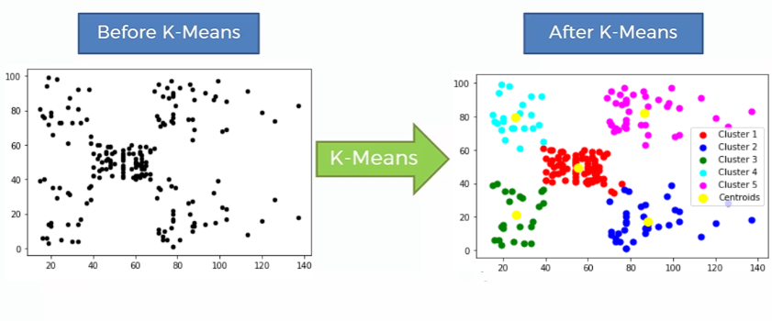

**Affinity Propagation:**

Affinity Propagation, unlike other standard clustering algorithms, does not require you to provide the number of clusters. In layman's terms, affinity propagation is a process in which each data point sends signals to all other data points, telling them of the relative attraction of each target to the sender. Given the attractiveness of the messages it has received from all other senders, each target then replies to all senders with a reply, telling each sender of its readiness to associate with the sender. Senders respond to targets with messages notifying them of their modified desirability to the sender based on the availability of messages received from all targets. The message-passing method continues until everyone agrees. When a sender is linked to one of its destinations, that target has now become the example for the point. All points that have the same reference are grouped together.

Affinity propagation has a quadratic algorithmic complexity in terms of the number of points. If the method fails to converge, it will still output an array of cluster centre indices and labels if any exemplars or clusters exist, but these may be degenerate and should be used with caution.Cluster_centres are still populated even if fitness does not converge, but it may be degenerate. Proceed with caution in this situation. If fit fails to converge and no cluster centers are produced, predict will label all samples as -1.When all training samples have the same similarities and preferences, cluster centers and labels are assigned based on the preference. Fit will result in a single cluster centre and label 0 for each sample if the preference is lower than the similarities. Otherwise, each training sample is allocated a unique label and becomes its own cluster centre.

**Pseudo code:**

runKmeansSA():

number of clusters=T/k

T ← OriginalDataset

for c in range(0, number of clusters) do

Pick a random trajectory from T, subtract it from T, and add it to cluster [c].

for I in range(1, k) do

for j in range(1, |T|) do

The trajectory should be added to the cluster [c].

Align according to DynamicSA, then save the information loss.

Remove the trajectory from cluster[c]

Add the itinerary that results in the least amount of loss to cluster [c],

then delete it from the dataset.

(T , Loss) ← dataGeneralization(originaldataset,clusters):

Return (T , Loss )

**ALIGNMENT:**

In order to reduce the total cost of generalisation, the process of alignment is described as finding the best fit between two trajectories. We use a multiple SA approach dubbed "progressive SA" for anonymizing spatiotemporal trajectories. The process of alignment between two trajectories has been investigated in several fields and is most commonly referred to as "sequence alignment" (SA). A greedy strategy for multiple SAs is a progressive SA. The method can select the trajectory resulting in the lowest loss during the alignment rather than selecting the trajectories at random during the progressive SA. The trajectories must be aligned pairwise as part of the method. Dynamic SA is used to carry out the pairwise alignment procedure. For this, we employ dynamic SA.Dynamic SA works by breaking the task of determining the optimal SA into smaller ones and storing the answers in a table or matrix called the SAmatrix. The matrix will retain the grid cell's lowest cost.

**Pseudo code:**

DynamicSA(src_lat,src_lon,cls_id,sa_correct,dt)

Create empty list.

SAmatrix ← np.zeros([m + 1, n + 1])

for i in range(m) do

calculate loss

SAmatrix[i + 1, 0] ← SAmatrix[i, 0] + Loss

for i in range(n) do

calculate loss

SAmatrix[0, i + 1] ← SAmatrix[0, i] + Loss

options ← np.zeros(3)

code ← list()

for i in range(m) do

for j in range(n) do

Loss ← loss incurred by generalizing pi and qj

options[0] ← SAmatrix[i, j] + Loss

Loss ← loss incurred by suppressing qj

options[1] ← SAmatrix[i + 1, j] + Loss

Loss ← loss incurred by suppressing pi

options[2] ← SAmatrix[i, j + 1] + Loss

options[2] ← SAmatrix[i, j + 1] + Loss

BestOption ← np.argmin (options)

SAmatrix[i + 1, j + 1] ← options[BestOption]

code.append(index of option with minimum value)

TotLoss ← SAmatrix[m, n]

return str(choosen_lat)+","+str(choosen_lon),TotLoss;

**GENERALIZATION:**

A well-known technique for publishing data while protecting privacy is generalization. The practice of generalization is a common defense against linked assaults. It operates by substituting duplicate forms for the original values in the micro data. By adding location and loss data, our model's user location will be generalized. Our suggested framework bases the anonymization of the spatiotemporal datasets on the generalization approach. We employ the domain generalization hierarchy (DGH) trees to implement this method, and we quantify the information loss in line with that, By advancing up one or more DGH levels, any node on a DGH tree can be generalized. Node-i →  Node-j is a symbol for the process of generalizing node-i to one of its parent nodes. Suppression is a specific type of generalization in which the node is extended to the DGH's root.

**Pseudo code:**

dataGeneralization(originaldataset,clusters):

Put the overall loss caused by using progressive SA in the TotalLoss store.

Let T be a set that is empty and used to hold the anonymized data.

for i in range(0, len(cluster)) do

Apply progressive SA on trajectories in cluster[i]

Add the incurred loss to TotalLoss

Append the generated trajectory to T

Return (T , T otalLoss)

**DATA FLOW DIAGRAMS:**

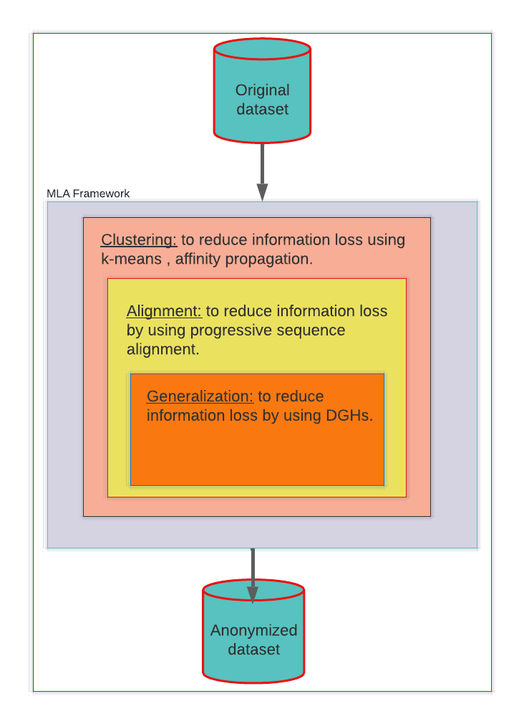

**CONCLUSION:**

While releasing the spatiotemporal trajectories, we have provided a system to protect user privacy. Progressive sequence alignment, an effective alignment technique, and a machine learning clustering strategy that strives to minimize loss throughout the anonymization process are the foundations of the suggested solution. Additionally, in order to ensure k-anonymity in excessively sensitive datasets, we developed a variant of the k-means method. The experimental outcomes on actual GPS datasets demonstrate that our suggested methodology outperforms earlier efforts in terms of spatial usefulness.

**SOURCE CODE:**

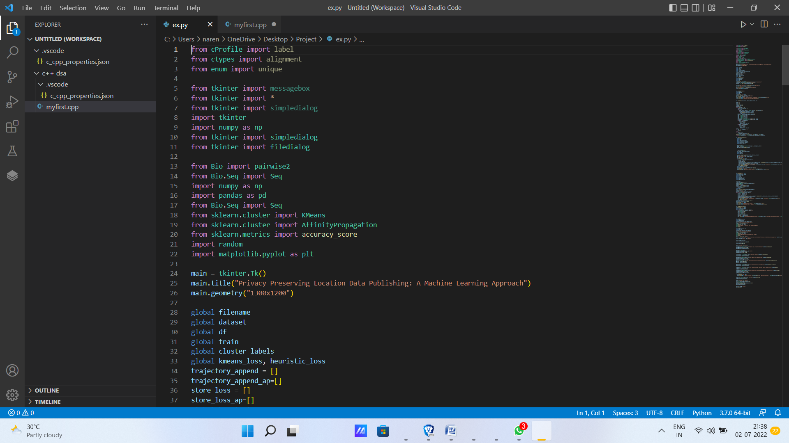

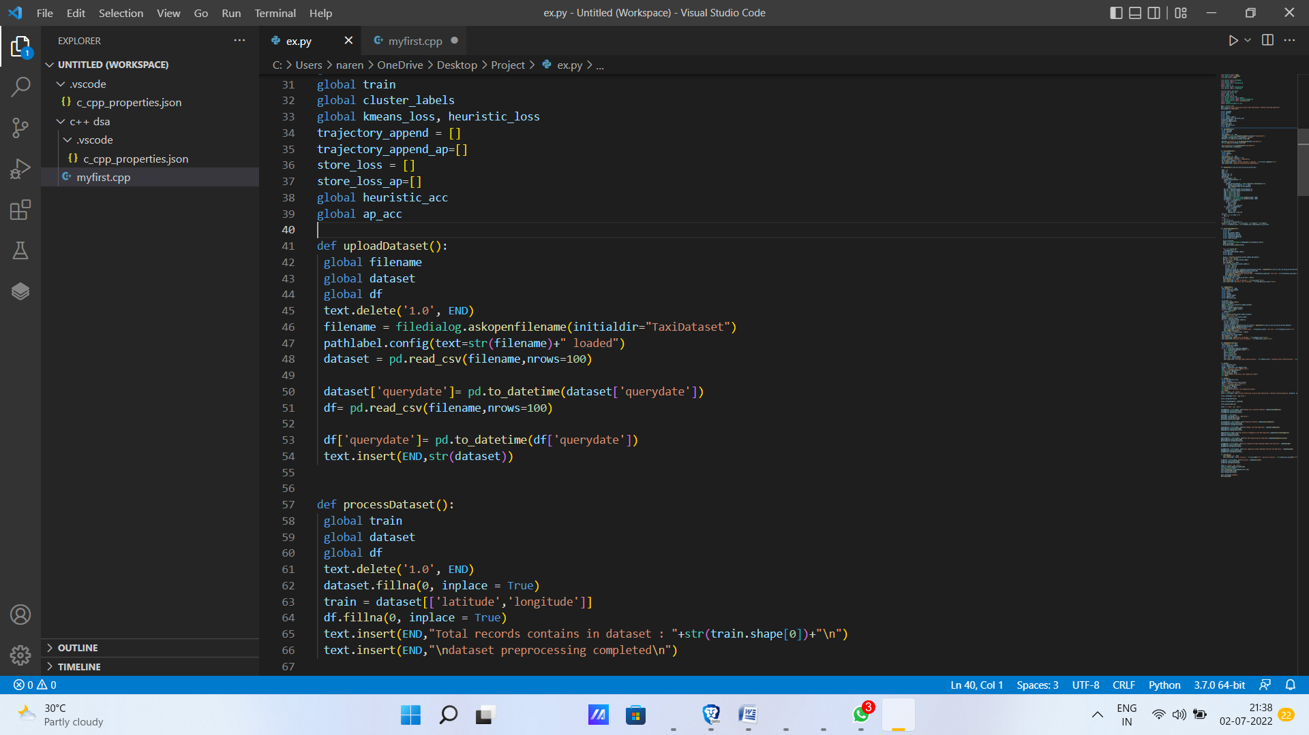

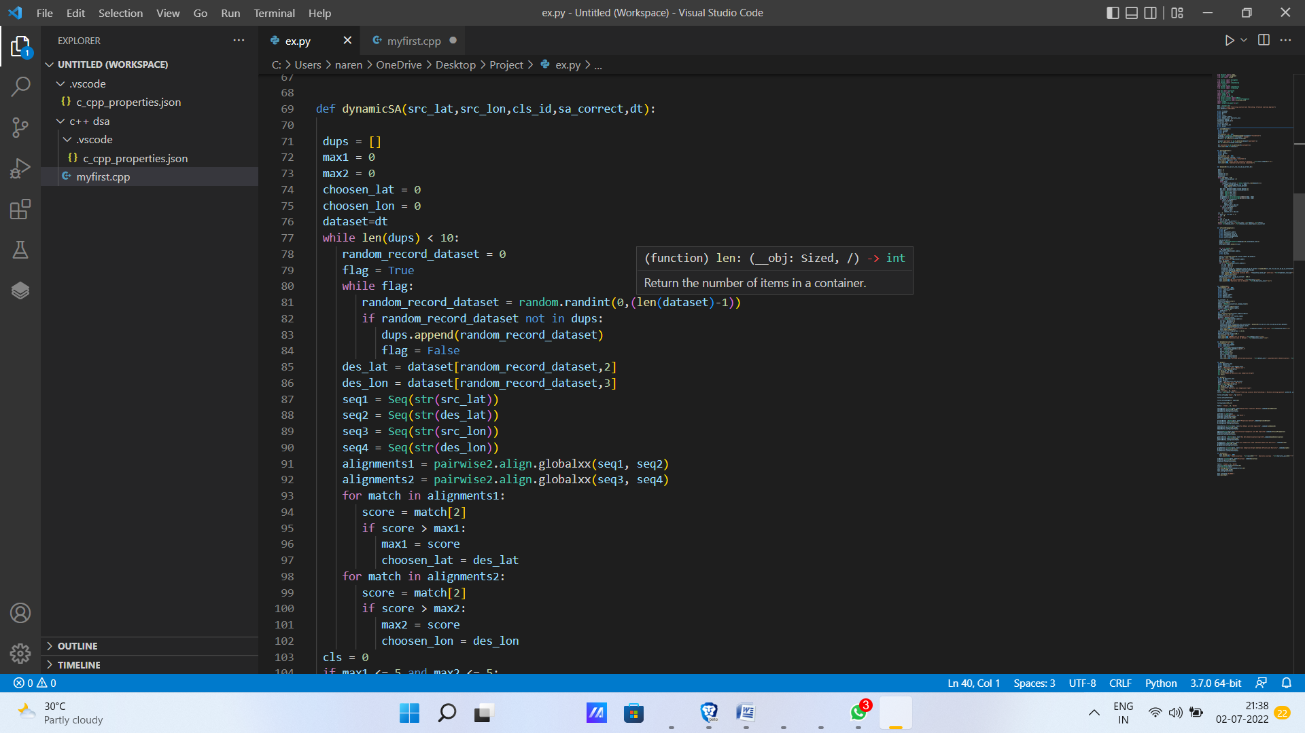

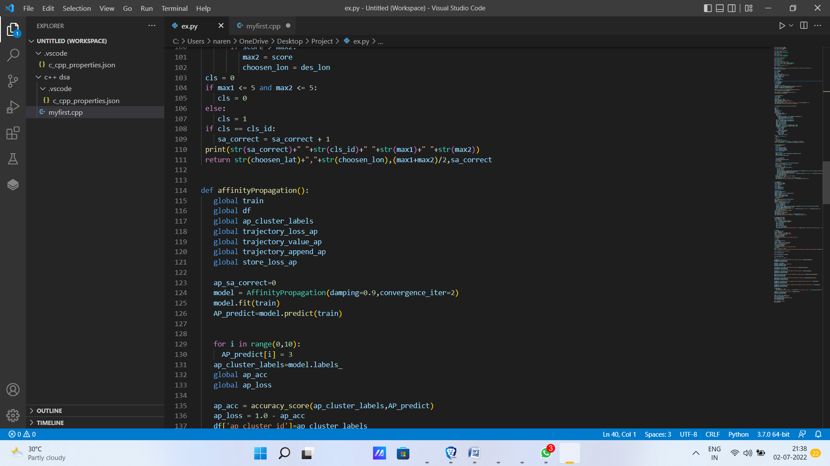

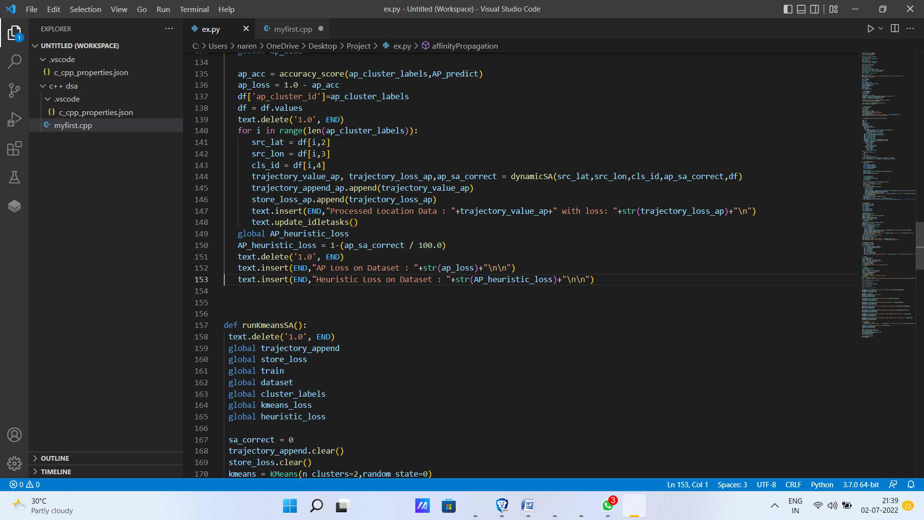

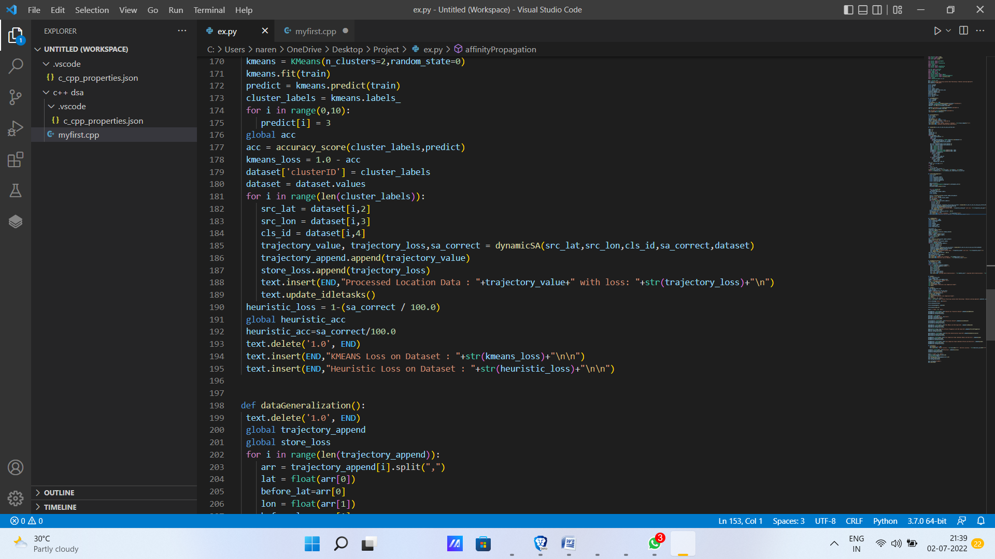

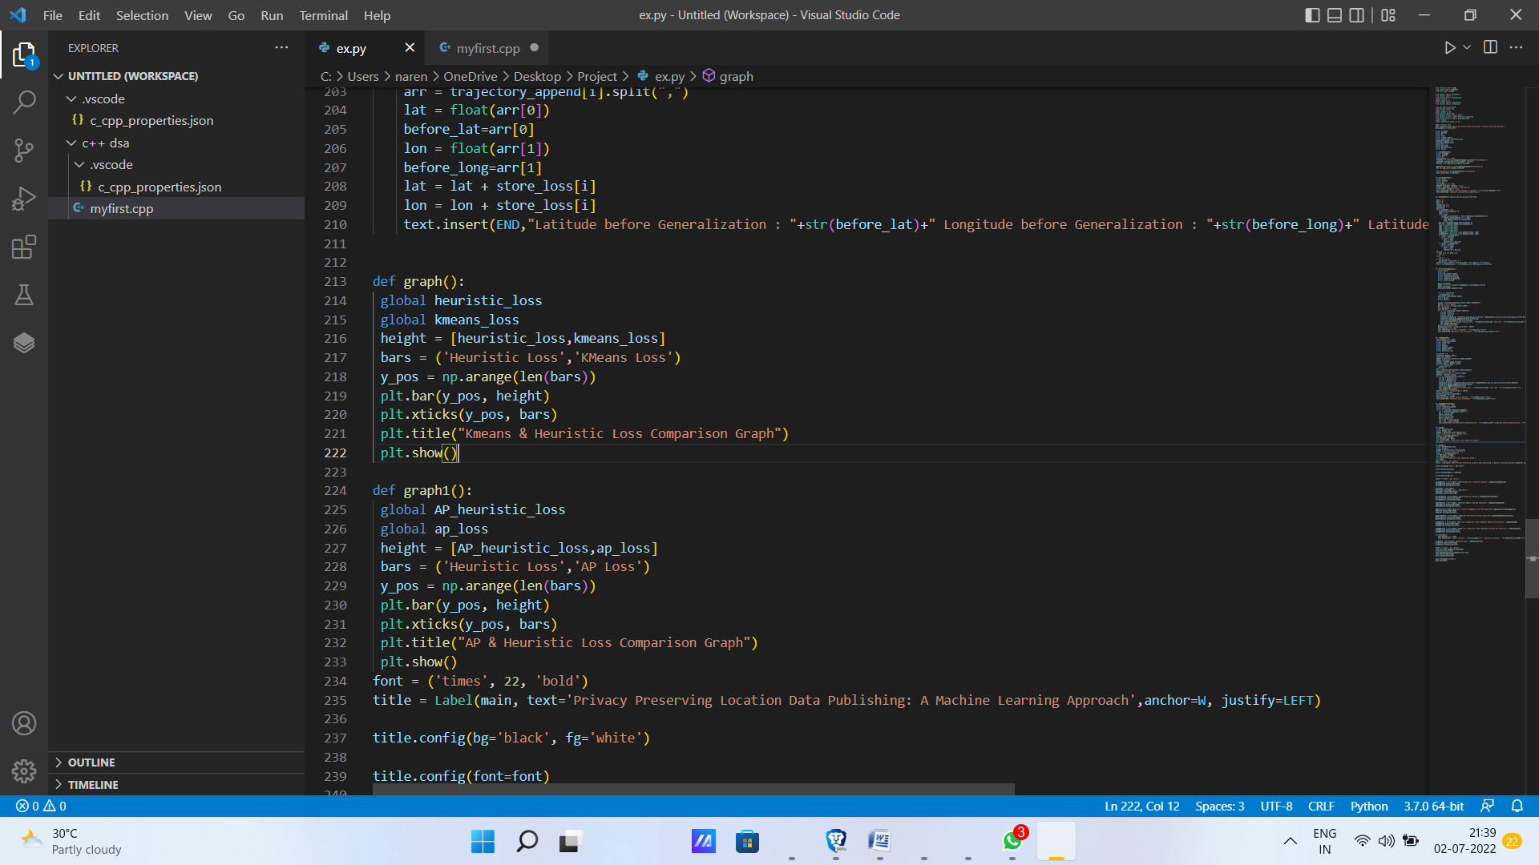

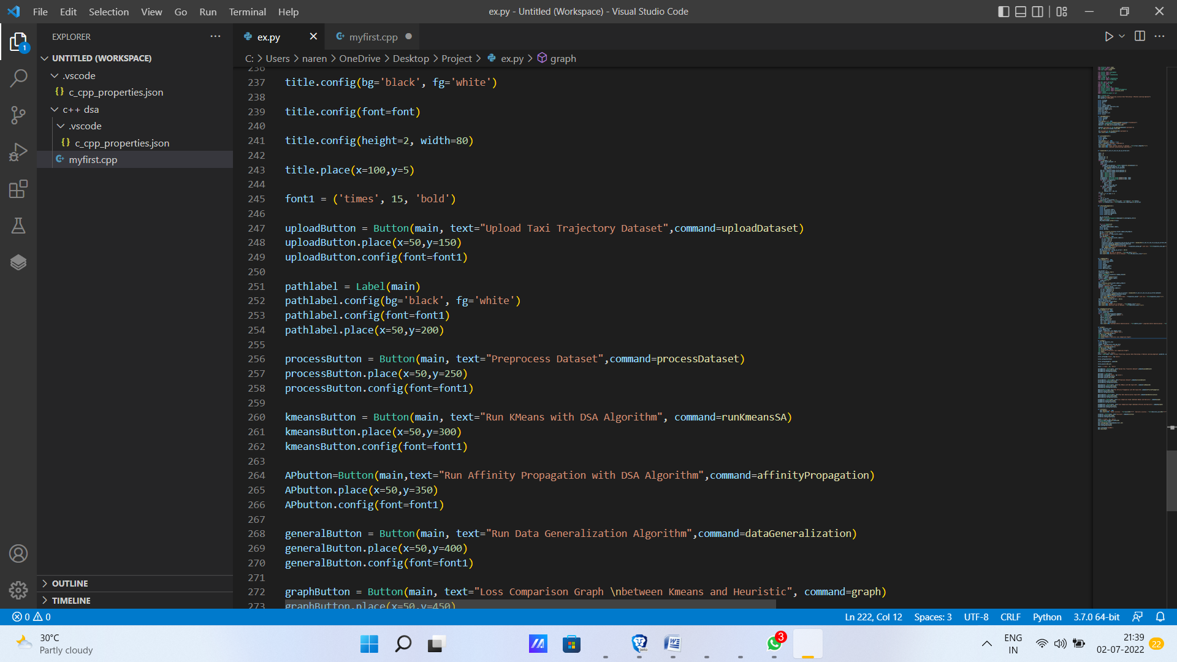

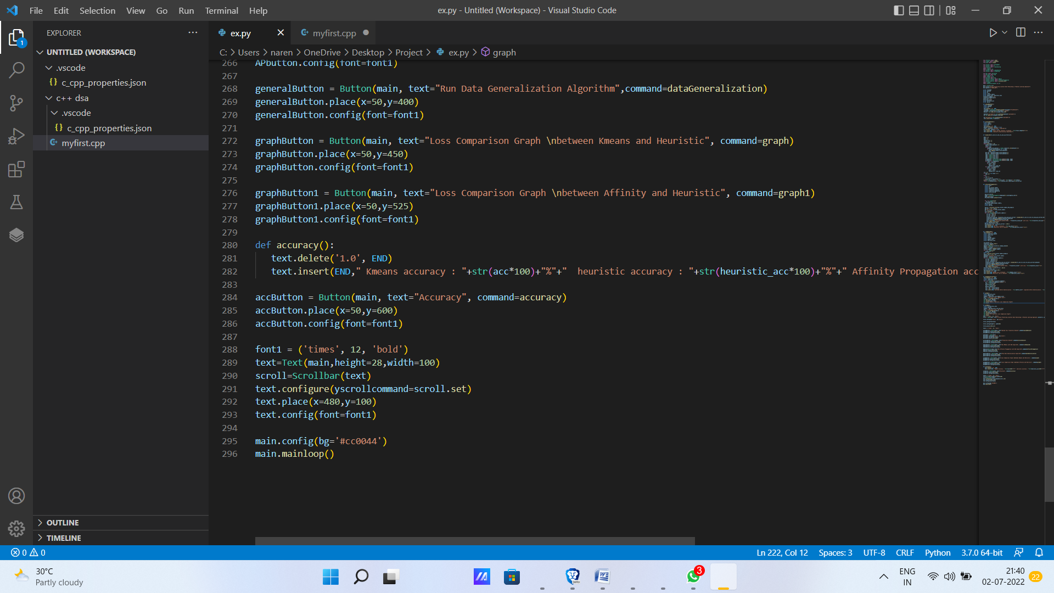

**RESULTS:**

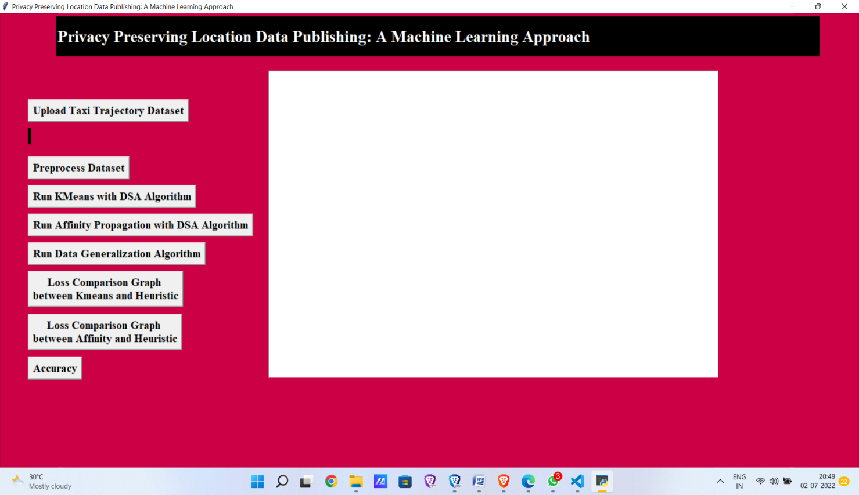

After running the above source code, the output screen looks like the above picture.

In above screen click on ‘Upload Taxi Trajectory Dataset’ button to upload dataset.



Select one of the dataset to upload.

In above screen selecting and uploading taxi trajectory file and then click on ‘Open’ button to load dataset and to get below screen.

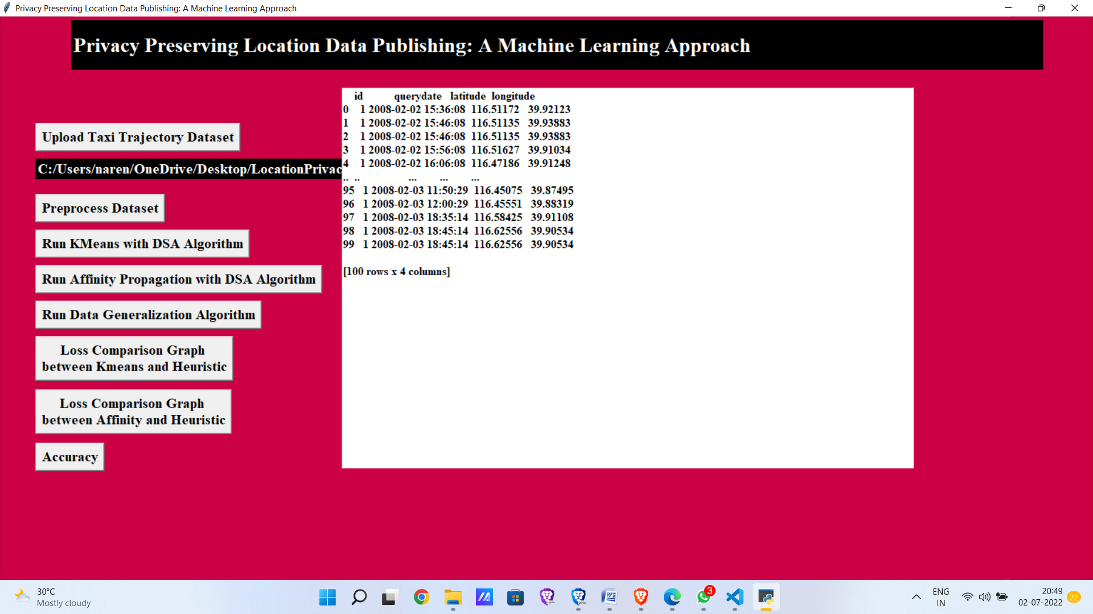

After, click Preprocess data button which performs data preprocessing on that dataset.

The idea of transforming unclean data into clean data is known as data preprocessing. Before running the algorithm, the dataset is preprocessed to look for missing values, noisy data, and other abnormalities. In above screen dataset loaded and now click on ‘Preprocess Dataset’ button to remove empty values and then extract latitude and longitude location from above dataset.

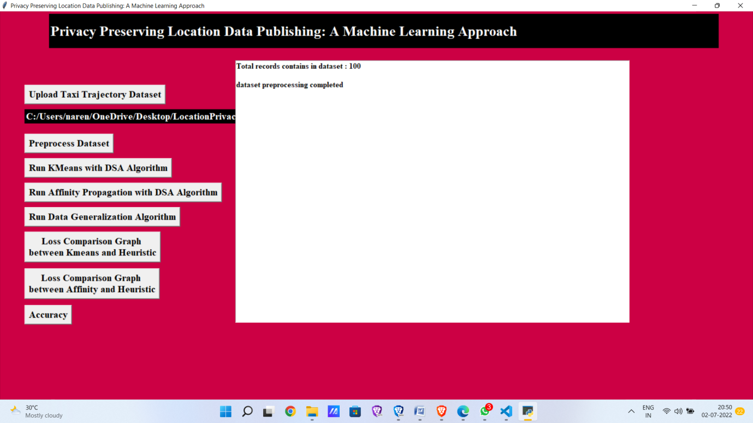

In above screen dataset pre-processing completed and now click on ‘Run KMeans with DynamicSA Algorithm’ button to run KMEANS on dataset with Dynamic SA. This algorithm will group all similar location into same cluster and then perform Dynamic SA.

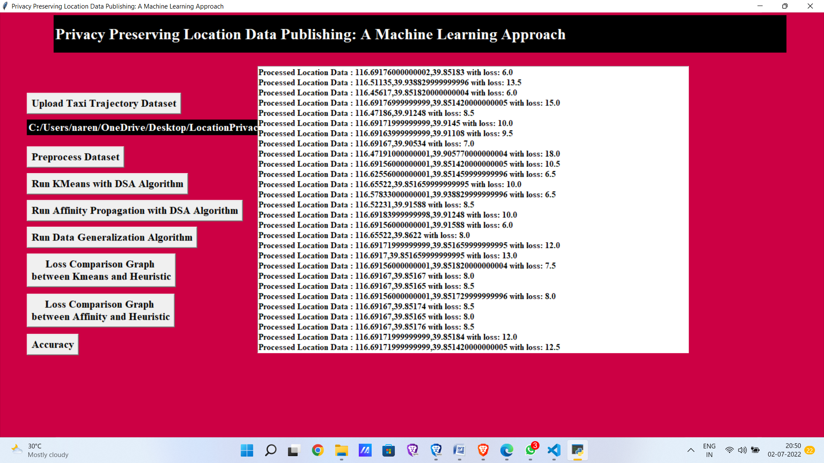

In above screen each location is processed and then calculating loss value with dynamic sequence alignment which align two locations by choosing minimal loss location.

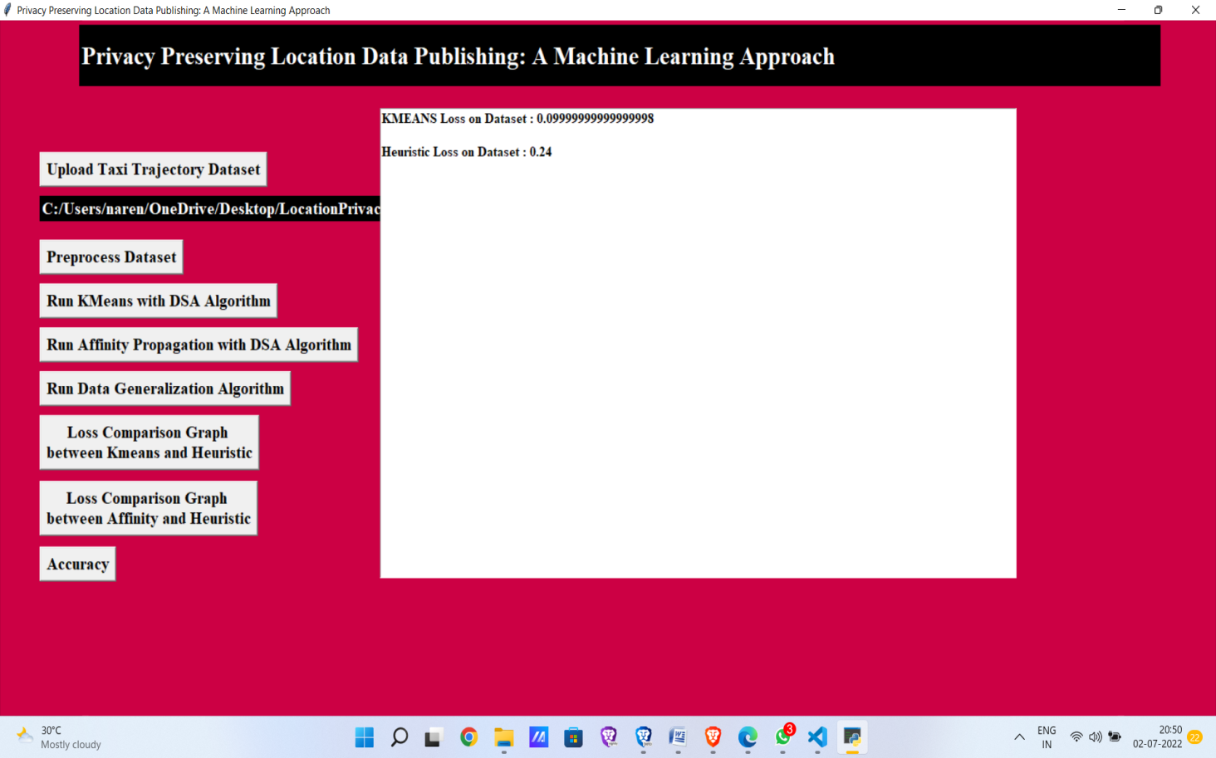

In above screen KMEANS loss is 0.09 and Heuristic Clustering (also known as Dynamic SA) loss is 0.24. Now click on ‘Run Affinity Propagation with DSA Algorithm’ button to run Affinity Propagation on dataset with Dynamic SA. Affinity Propagation, unlike other standard clustering algorithms, does not require you to provide the number of clusters.

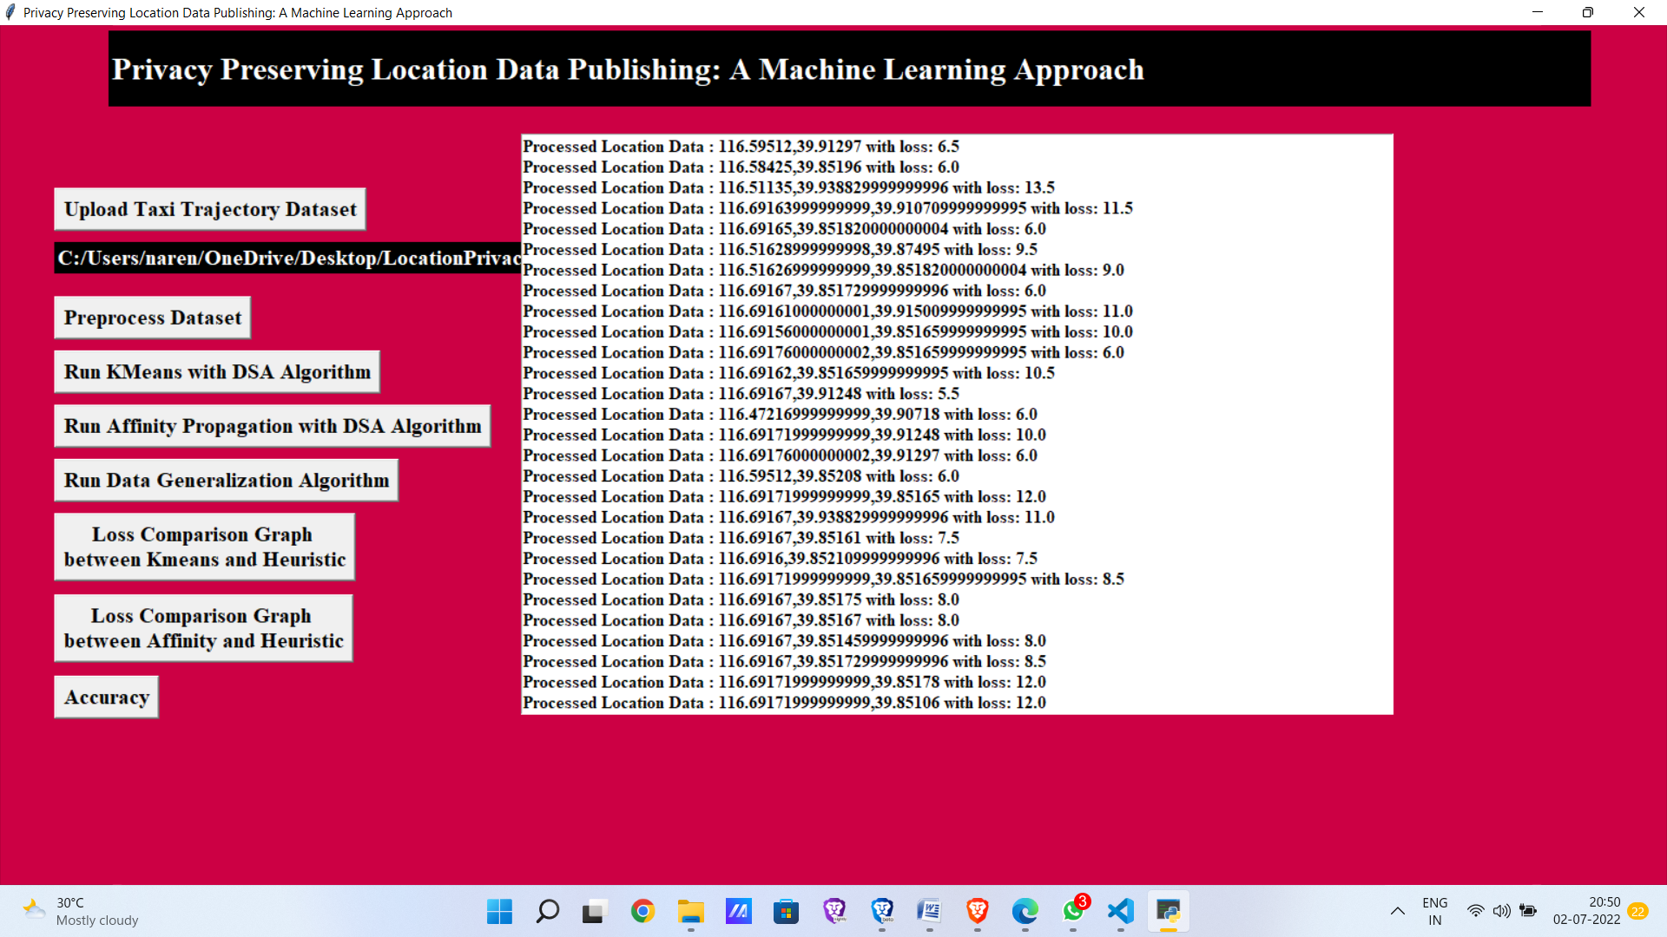

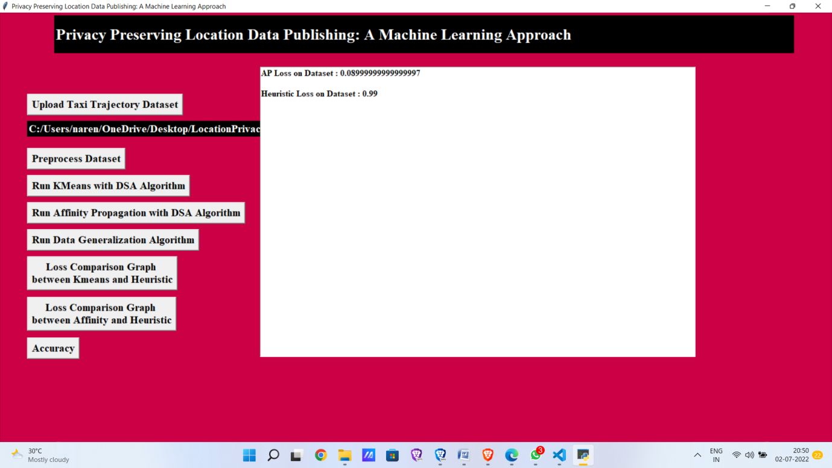

In above screen Affinity Propagation loss is 0.09 and Heuristic Clustering loss is 0.99.

Now click on ‘Run Data Generalization Algorithm’ button to generalized data with loss value.

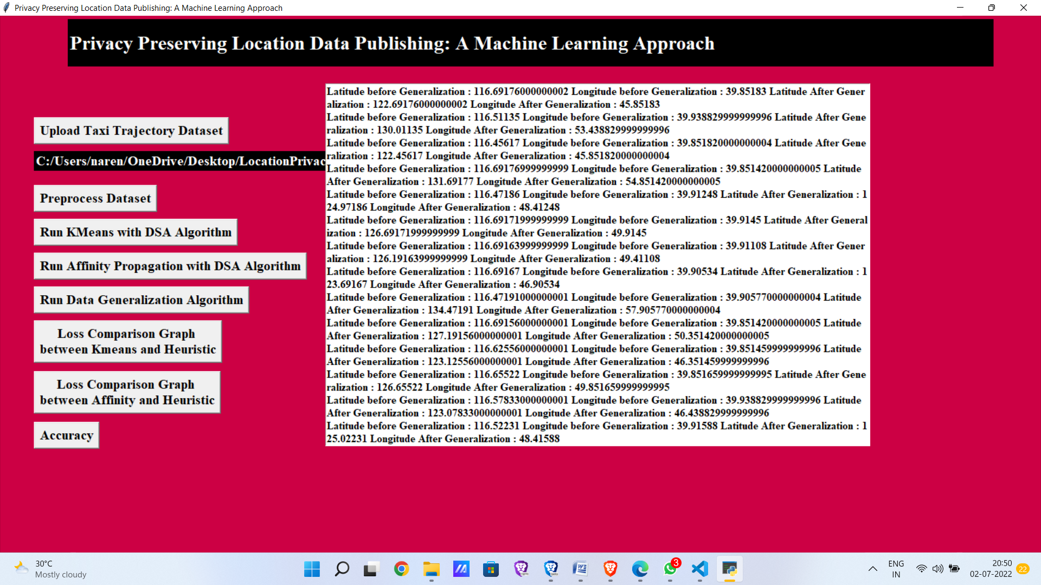

In above screen in first record you can see real location values from dataset and in next same location was generalized with loss value. Now click loss comparison graph b/t kmeans and heuristic.

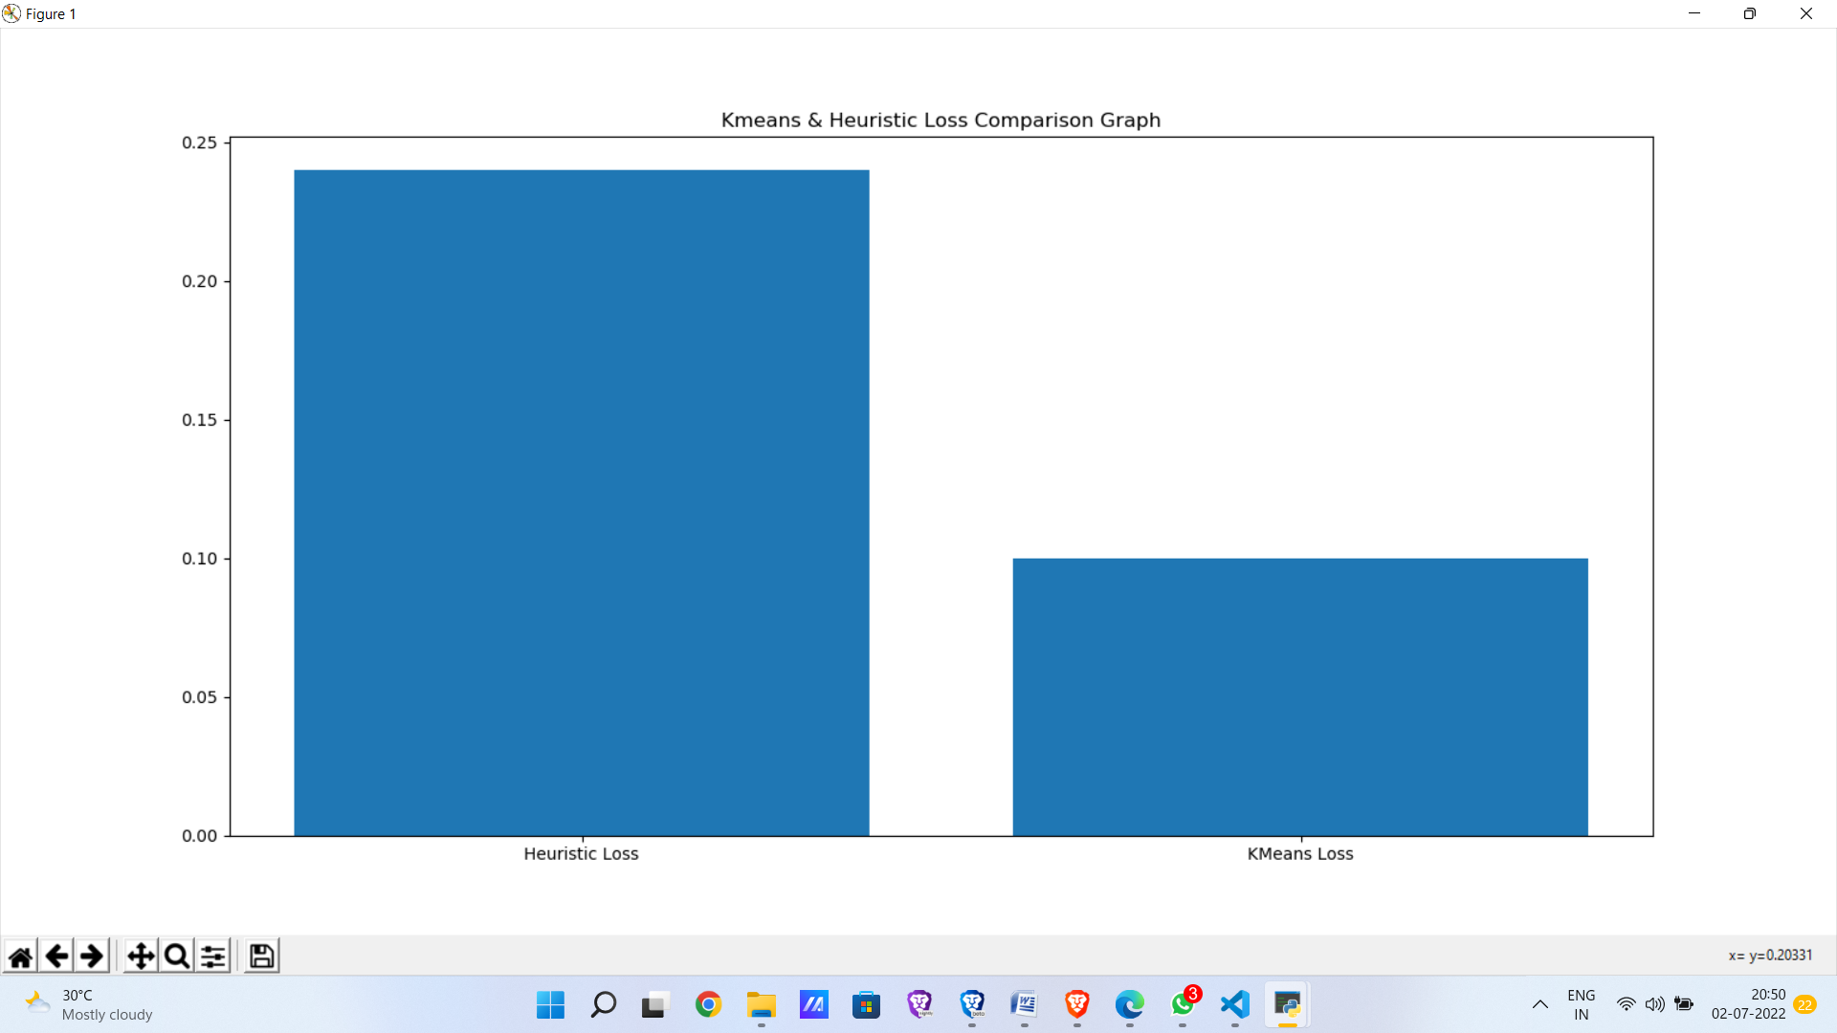

Now click loss comparison graph b/t Affinity propagation and heuristic.

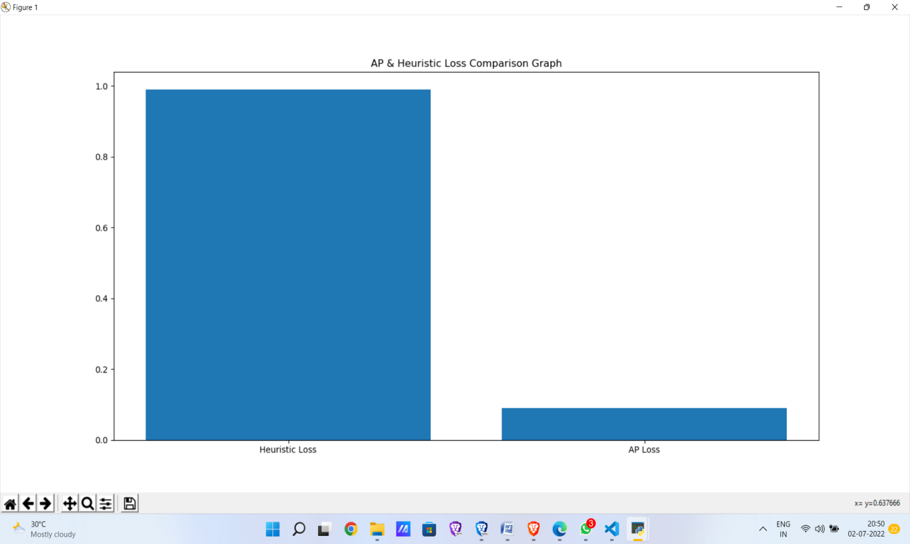

Now click Accuracy.

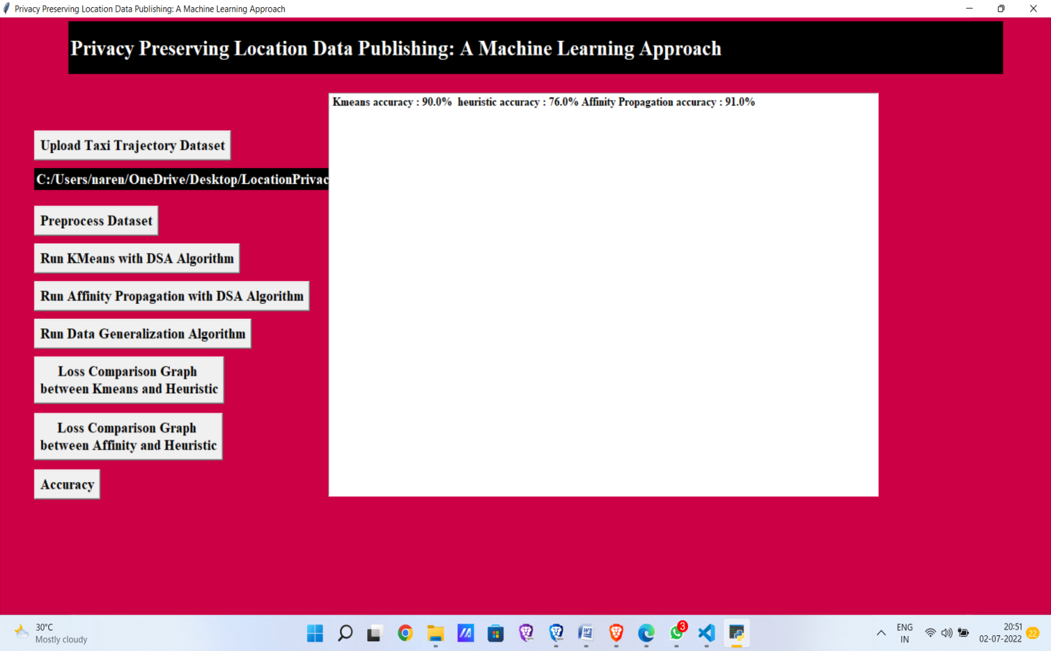

Accuracy indicates how much the predicted value is closer to the correct value in percentage . Higher the accuracy indicates better the algorithm.

In the above screen it shows K-Means accuracy is 90%, Affinity propagation accuracy is 91% and final Heuristic accuracy is 76%.

**REFERENCES:**

1. S. Shaham, M. Ding, B. Liu, Z. Lin, and J. Li, “Machine learning aided anonymization of spatiotemporal trajectory datasets,” arXiv preprint arXiv:1902.08934, 2019.
2. O. Asan, F. Cooper II, S. Nagavally, R. J. Walker, J. S. Williams, M. N. Ozieh, and L. E. Egede, “Preferences for health information technologies among us adults: Analysis of the health information national trends survey,” Journal of medical Internet research, vol. 20, no. 10, p. e277, 2019.
3. F. Rahman, P. Karanikas, and T. D. Giles, “Systems and methods for creating contextualized summaries of patient notes from electronic medical record systems,” Aug. 17 2017, uS Patent App. 15/430,401.
4. J. Colleti Junior, A. B. d. Andrade, and W. B. d. Carvalho, “Evaluation of the use of electronic medical record systems in brazilian intensive care units,” Revista Brasileira de terapia intensiva, vol. 30, no. 3, pp. 338–346, 2018.
5. S. K. Pal and P. P. Wang, Genetic algorithms for pattern recognition. CRC press, 2019.
6. Q. Le, F. Sievers, and D. G. Higgins, “Protein multiple sequence alignment benchmarking through secondary structure prediction,” Bioinformatics, vol. 33, no. 9, pp. 1331–1337, 2020.
7. Agrawal, K. P., Garg, S., Sharma, S., & Patel, P. (2018). Development and validation of OPTICS based spatio-temporal clustering technique. Information Sciences, 369, 388–401.
8. Nasir A,Mashor A S,Mohamed M,et al.Enhanced K-Means Clustering Algorithm for Malaria Slide Image Segmentation[J] .Journal of Advanced Research in Fluid Mechanics and Thermal Sciences,2018,42:1-15
9. Yuan Luyan, Li Feng. The application of improved association rule Apriori algorithm in course score analysis [J]. China Education Information Technology, 2017, 18 (17): 62-65.
10. Zeng Xing. Research on student performance analysis based on association rule mining [D]. Haikou: Hainan University, 2018.
11. Wu Wenling. Curriculum correlation analysis and application research based on data mining technology [D]. Chengdu: Sichuan Normal University, 2019.
12. Liu Yuqiao. Research and application of cluster analysis and association rule technology in performance analysis [D]. Wuhan: Central China Normal University, 2014.
13. H,Anrisa A.An analysis of MapReduce efficiency in document clustering using parallel K-means algorithm[J].Future Computing and Informatics Journal,2018,3(2):200-209.
14. C. Romero-Tris and D. Meg´ıas, “Protecting privacy in trajectories with a user-centric approach,” ACM Transactions on Knowledge Discovery from Data (TKDD), vol. 12, no. 6, p. 67, 2020.